[Test Plan] User Management version 1.0

Document Status | [DRAFT] [REVIEWED] [FINAL]
Test Plan Creator | Ananda Arta
Test Plan Reviewer | - Arta

Introduction

Overview Feature to be tested
The Test Plan has been created to communicate the test approach to team members. It includes the objectives, scope, schedule, risks and approach. This document will clearly identify what the test deliverables will be and what is deemed in and out of scope.

Goals and Objective

Test Case Tamer is a web-based Test Management tool used to create and store tests as well as the results of running those tests. This tool is a new product written with Ruby on Rails using a ‘mysql’ database. The test team is responsible for testing the product and ensuring it meets their needs. The test team is both the customer and the tester in this project.

Test Item
List of test items (feature / product)

No | Feature | Test Item
#1 | Login | - Login with valid credentials  - Login with invalid credentials  - Login with user doesn’t exist
#2 | Add User | - Add with valid credentials  - Add with invalid credentials
#3 | Logout | - Function logout work properly

In Scope Testing
List of in feature to be tested

No | Feature | Requirement / Design specifications
#1 | Login | 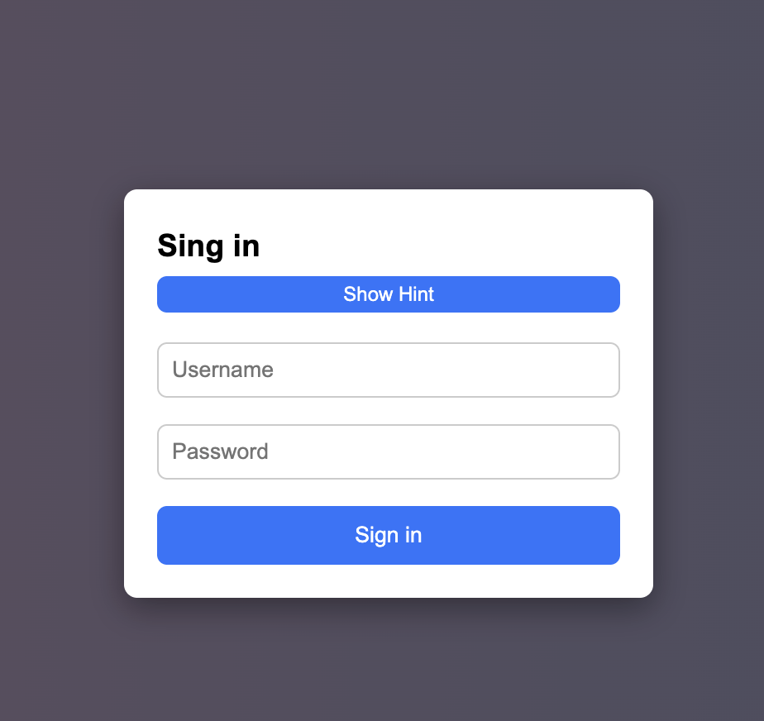
#2 | Add User | 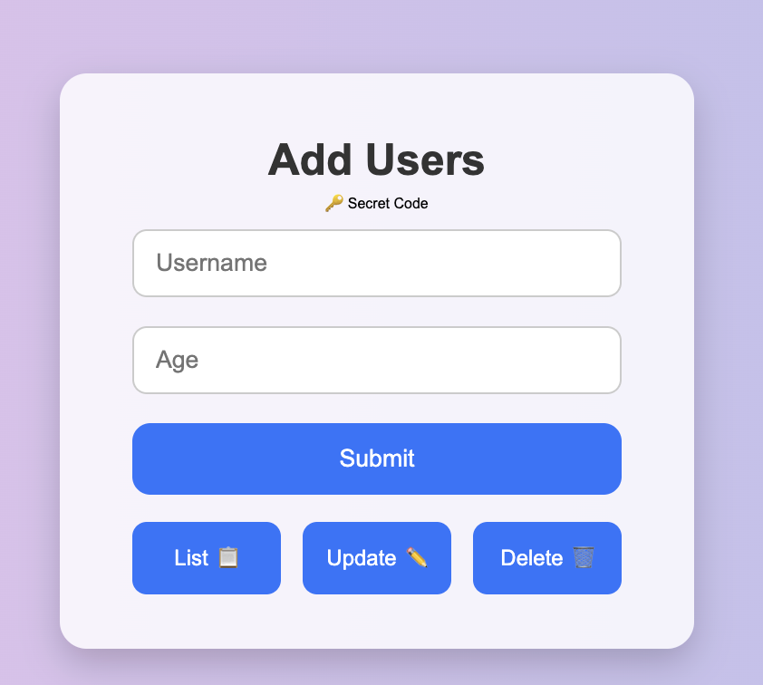

Out of Scope Testing
List the features of the software / product which will not be tested.

No | Feature | Reasons
#1 | Logout | This testing phase will be focus to test login feature and add user

Testing Approach
Summary of testing approach that will be implemented during testing phase

The testing process uses Exploratory testing type because the tester does not know from the beginning the process of making the saucedemo.com website. So that the tester explores the website to test whether the website is suitable and can be used by users without any problems.

Test Environment
Information about testing environment that will be used during testing phase e.g URL, and version of App
- Website: https://belajar-bareng.onrender.com/
- Android version: v1.1.1
- iOS version: v1.2.0
- Env:Dev/Staging/Production
- Browser: Edge, Chrome, Firefox

Test Deliverables
- Test Plan (this document itself): [link]
- Test Case: [link]
- Test Script (if any): [link]
- Test data (if any): [link]
- Defect Report: [link]
- Test Report: [link]

Testing Timeline

No | Task | Estimation Time |  | Actual Time
No | Task | Start Date | Finish Date | Start Date | Finish Date
#1 | Develop Test Planning | 6 Des 2025 | 6 Des 2025 | 6 Des 2025 | 6 Des 2025
#2 | Develop Test Case | 7 Des 2025 | 7 Des 2025 | 7 Des 2025 | 7 Des 2025
#3 | Test Case Review | 8 Des 2025 | 8 Des 2025 | 8 Des 2025 | 8 Des 2025
#4 | Execute Test | 9 Des 2025 | 9 Des 2025 | 9 Des 2025 | 9 Des 2025

References
List of related documents e.g PRD, Figma design, API Contract, Copy document etc

API Contact: [link],
Design: [Figma]

